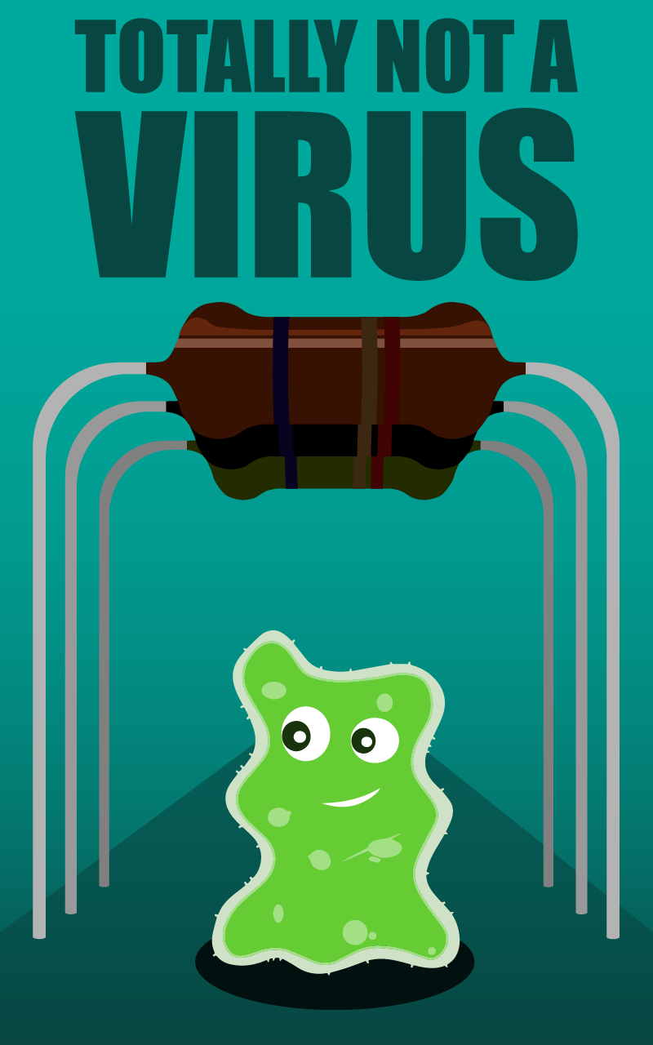

**Totally Not a Virus**

*Backstory*

Sammy is a young and ambitious flu virus. Sammy was born in a huge family (Influenza, also known as the common flu) with thousands and thousands of brothers and sisters. And as you might expect - Sammy wasn’t quite like them. He was always on the search of something more, something special.

The young and curious Sammy was playing one day with some of his friends – LG5132 and LG5133 (They had strange names because they weren’t viruses like Sammy. They were white blood cells and that’s why they weren’t allowed to play together.) when all of a sudden, Sammy’s dad called him by name.

“I’m in big trouble!”, exclaimed Sammy as he started to run towards his father’s voice. 1 minute and several wrong turns later and Sammy managed to get lost in his host’s body. Oh, and his host? – The 24-year-old human programmer Asen, also very ambitious and curious, just like Sammy. In this exact moment Asen was changing some part on his desktop computer.

Something fell into Asen’s eye. He sneezed violently and that’s how the tiny little flu-virus named Sammy found himself on a computer motherboard.

*Sammy’s main motivation is to explore this new world (the Motherboard) and he meets some of the NPCs along the way that mentor him into becoming “just like them” – a real computer virus. It is obvious that such thing is practically impossible and a flu virus cannot become a computer virus. But Sammy still does try guided by the 3 mentors along the way.*

*Main level progression: Sammy explores (walks through) several screens/areas while doing the task he’s been given by the according NPC in the starting area. After every exploration there’s a boss level (duel). The progression goes as follows:*

***First area (Meeting the 1st NPC) -> Exploration of the first area and completing a task given by the NPC -> retrieving an Item from the NPC after completion of the task -> boss level (duel) -> Second area (Meeting the 2nd NPC) -> … (and so on)***

**NPCs**

**Spam Virus**

A spam virus (can look like a letter (mail)) who’s only job is to send malicious/undesired mail to millions of people around the world.

***Example conversation:***

Spam Virus – “*Hello there, I’m a Spam Virus! My job is to send millions of emails every day about male enhancing products and money scams!”*

Sammy – *“So basically – Viagra and pyramid schemes?”*

Spam Virus – *“Well… yes, basically… But I’m the best at my job! Everyone hates me and everyone knows my name!”*

Sammy – *“I guess you’re right… I’ve been hearing about you on the news… Can I be just like you?!”*

Spam Virus – *“Are you sure you have it in you, you young fellow? I have a task for you: “ –* Proceeds to give a task about the current rooms/areas to eventually explore and collect something. For example electrons. After collecting N count electrons, Sammy has to speak with the Spam Virus again and then gets an item from him.

**Malware**

A virus software. Makes people’s lives a living hell. Jokes around with people and moves their files around or deletes entire folders. Hates antivirus programs and knows how to go around them.

**Trojan Horse**

The most powerful/feared of all the viruses on the Motherboard. Everyone answers to him and tries not to get in his way. The Trojan Horse can control the whole computer but often times chooses not to. He is just power-hungry and likes that everyone is scared of him.

**Bosses**

**The mother Resistor**

The biggest of all the Resistors. Has around the same HP as Sammy.

Abilities:

* Meditation – By the power of Ohm, resists X damage.
* Electrocute – Basic attack, does X damage.
* Voltage Current – Ultimate attack, does the most damage but can be used once every X turns/moves.

**The RAM**

First friends with the CPU. Very powerful and feared by the Malware.

Usually very hard to kill and very easily replaceable. Has 1.5x the HP of Sammy.

Abilities:

* Backup – resists X damage.
* Memory overloading – Basic attack, does X damage.
* Memory wall – Ultimate attack - Stops the opponent from attacking X turns.

**The CPU**

The most powerful of all the hardware on the Motherboard. If the

hardware was a mafia family, the CPU would be their Godfather. Has 2x the HP of Sammy

Abilities:

* Emergency shutdown – resists X damage.
* Processing – Basic attack, does X damage.
* Hyper-threading – Several attacks at once, does a lot of damage.

**Items**

**Stick**

A regular wooden stick that can be used for a lot of things. The stick is given out by the first NPC – the Spam Virus after completing his task. The stick can be used in boss fights. The stick also unlocks the arcade-style shooting of splinters while in the Areas/Zones (not in duel).

Unlocks Abilities:

* Block with a stick – basic block, blocks X damage.
* Hit with a stick – basic attack, does X damage.
* Waltz with a stick – dummy move (does nothing), result is – “Why would you dance with a stick in a middle of the fight?!”

**Knife**

Regular kitchen knife. The knife is given out by the Malware after the

completion of his task. (*Knife can unlock arcade-style melee attack while in the Areas/Zones.)* The knife changes the Stick into Pointed Stick

Unlocks Abilities:

* Block with a knife – basic block, blocks X damage.
* Slice with a knife – basic attack, does X damage.
* Stab with pointed stick – does 1.5 times X damage, but has a small chance to miss the target.
* Cut onions with knife – dummy move (does nothing), result is – “Good job, you made your opponent cry. Are you happy with yourself? Look at the poor thing!”

**Chainsaw**

The mother of all weapons. The chainsaw is given out by the Trojan

Horse after the completion of his task. The chainsaw does a lot of damage but can be used limited amount of times:

Unlocks Abilities:

* Chainsaw Massacre – does a lot of damage
* Carve a sculpture with the Chainsaw – dummy move (does nothing), result is – “You carved a beautiful sculpture with your heavy WEAPON. And how does that help you with the fight exactly?!”